School of Computer Applications
Department of Master of Computer Applications
SEM Examination Summer – 2026
Semester – II
Class Test – II Practical Exam
Sub Code: 240110203 | Division: E | Total Marks: 50 (including VIVA)
Sub Name: Object Oriented Programming with JAVA (OOPJ)
SET-1
A | Stack + Thread Priority [20 Marks]  Write a Java program to demonstrate Thread Priority using Stack.  The program should perform the following:  • Create 3 threads — HighPriorityThread (priority 10), MediumPriorityThread (priority 5), LowPriorityThread (priority 1).  • Each thread pushes its name + priority as a String into a shared Stack<String>.  • Use setPriority() and getPriority() methods. Display each thread's name and priority before starting.  • After all threads complete (use join()), pop all elements and display them.  • Also demonstrate peek() to view the top element before popping.  • Display 'All tasks completed. Stack size: X' at the end. | 20
B | Swing – Shopping List App [20 Marks]  Design a Shopping List application using Java Swing:  • JTextField for item name and JTextField for quantity.  • JCheckBox — 'Mark as Urgent' (if checked, prefix item with [URGENT]).  • JButton — 'Add to Cart', 'Remove Selected', 'View Cart'.  • JList<String> with JScrollPane to display cart items.  • JLabel showing total items in cart.  • On Add to Cart → add 'ItemName - Qty: X' (or '[URGENT] ItemName - Qty: X') to JList.  • On Remove Selected → remove selected item from list.  • On View Cart → display all items in a JOptionPane message dialog.  • Use BorderLayout or GridBagLayout.  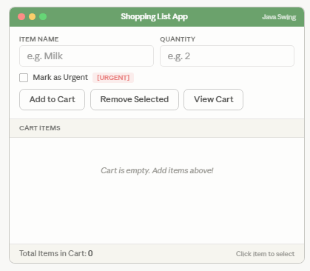 | 20
 | Viva | 10

